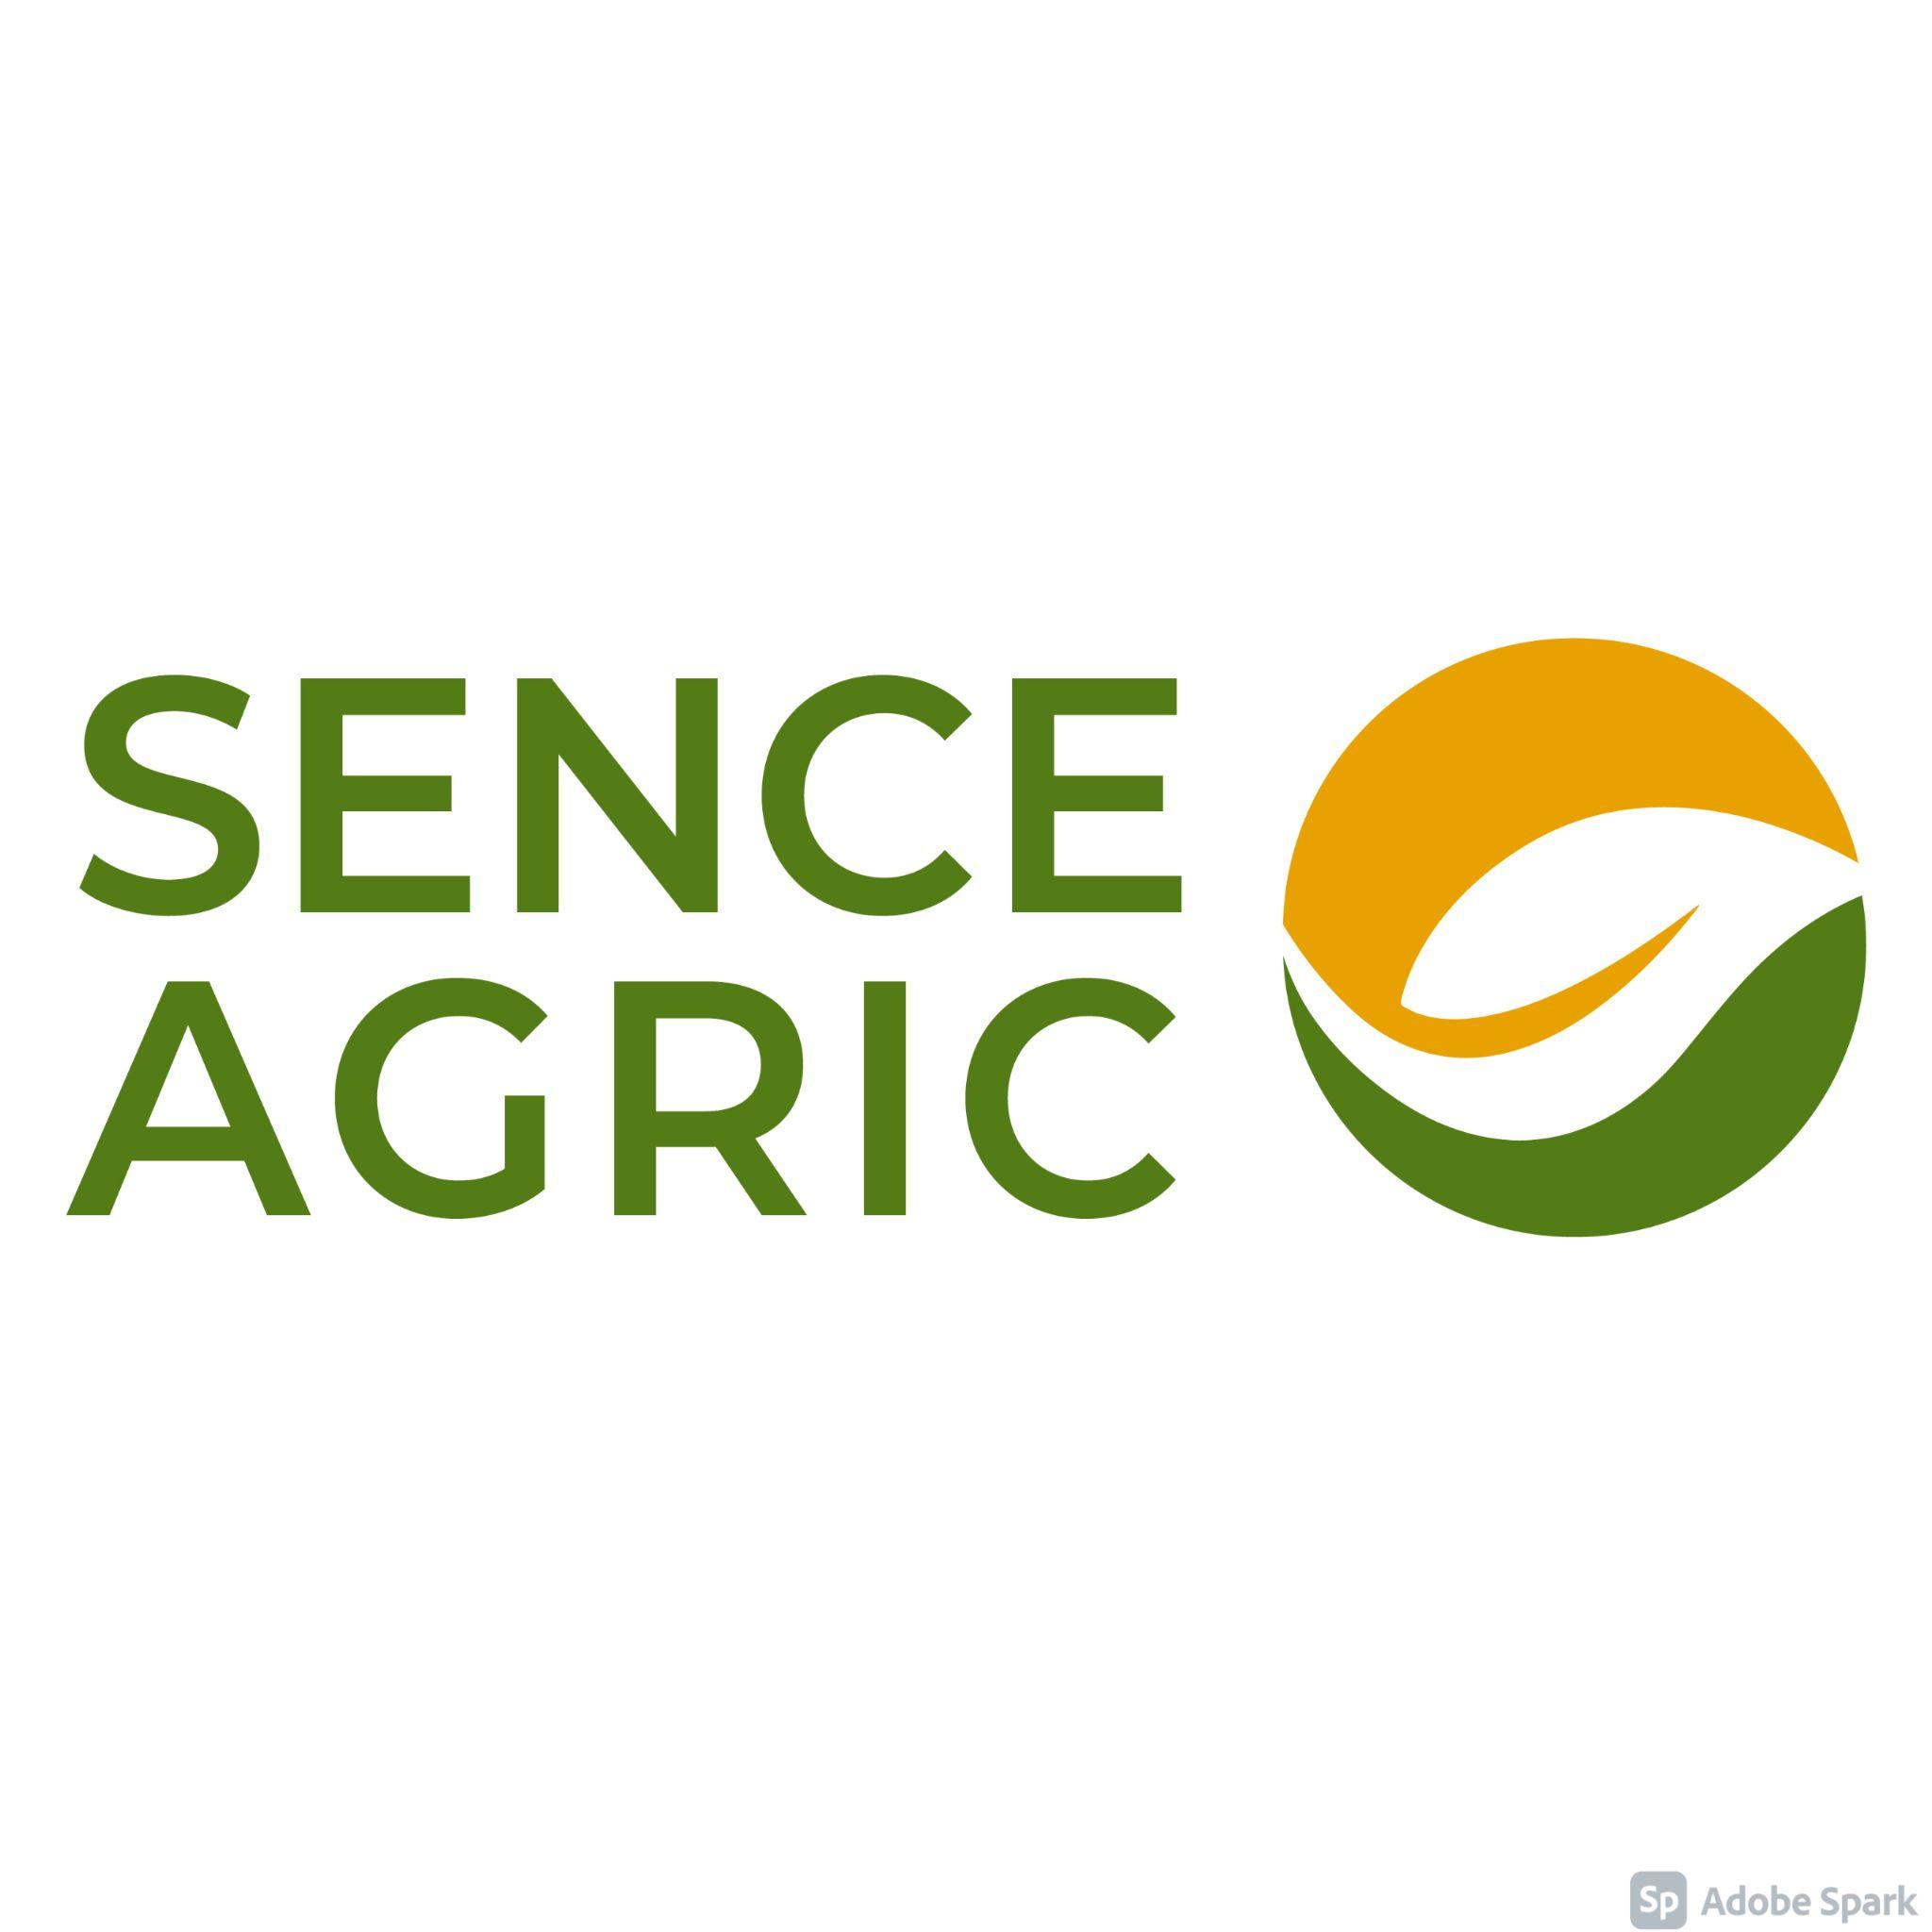
PAID AGRICULTURE INTERNSHIP OPPORTUNITY IN DENMARK

SENCE Agric, a sister company to SENCE Limited in collaboration with Bixter.dk ApS, an international organisation specialised in providing valuable traineeship programs in agriculture, is looking to recruit agriculture students in tertiary institutions who are looking for internship opportunities. Successful candidates should be currently enrolled in a livestock related course and must be ready to take a gap year to work in Denmark for a period of 12 - 18 months in a livestock farm. This opportunity is Ideal for OND students who want to take a 1 year gap before commencing HND. Successful interns must return back to complete their education at the end of the program.
REQUIREMENTS
In order to be eligible for this program, interested candidates must:
- Be currently enrolled in any tertiary institution (from 2nd year) studying Agriculture with focus on livestock, Animal Science, Veterinary, Zootech or related courses with focus on livestock.
- Be passionate about building a career in agriculture
- Be passionate about pursuing a career in agriculture
- Be within the ages of 18 - 29.5 years as at the time of application.
- Must have passed an English proficiency test: This can be either be
  - IELTS; minimum score of 3.0 band or
  - TOEFL; Cbt: minimum of 200 points, Pbt: Minimum of 533 points, Ibt: 72 points
BENEFITS:
This traineeship opportunity comes with several benefits which includes:
- An opportunity to put what has been learnt in the classroom into practice and also gain practical experience in a modern farm.
- An avenue to gain exposure and experience new culture
- An opportunity to learn more about modern agricultural techniques in the livestock industry from established farms.
HOW TO APPLY
To apply kindly follow the links below
Internship - https://cutt.ly/vMoJoYB

